***7Vals test***

* IS NULL AND = NULL IN SQL

= “NULL” if record contain string NULL

IS NULL if record is unknown

* 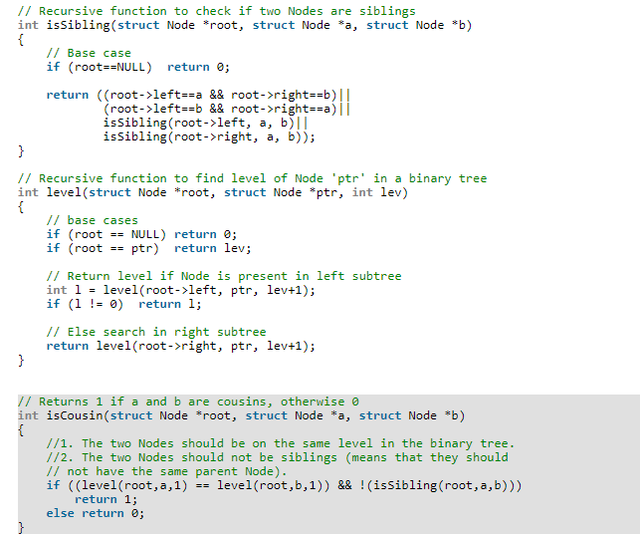
* 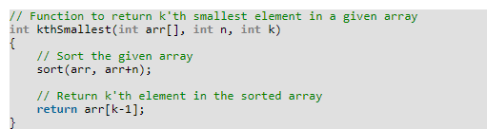
* 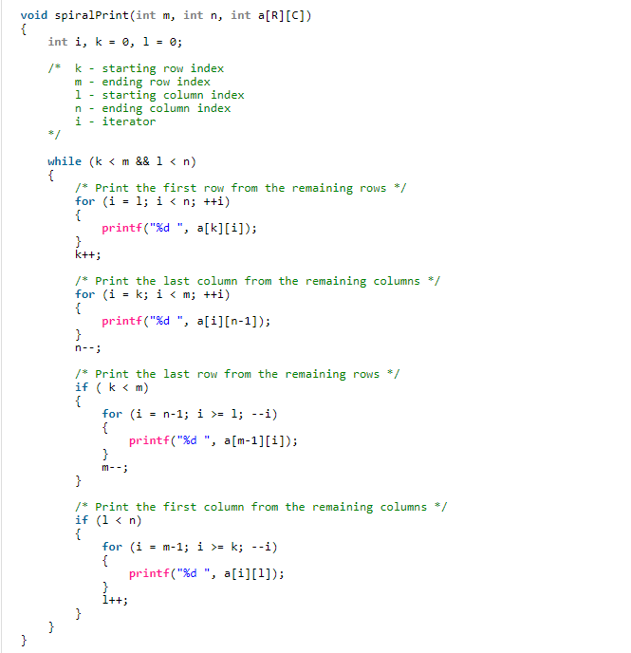
* Return type of method is not part of method signature, so just changing the return type will not overload a method in Java.  In fact, just changing the return type will result in compile time error as "duplicate method X in type Y. Here is a screenshot of that error in Eclipse :  
    
  Read more: <http://www.java67.com/2012/09/what-is-rules-of-overloading-and-overriding-in-java.html#ixzz5BQakGSqP>
* 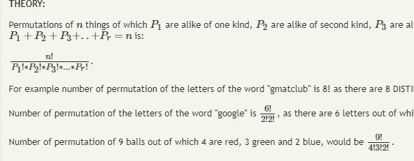

***TKxel test***

* 
 